Requirement Analysis

Last update：2020-5-19

version：V1.0

author：Dean Peng

**1、Requirement summary**

**1.1 *Position changed based on each transaction happen***

**2、Requirement analysis**

**2.1 position change**

display Equity position, this page have Refresh/Buy/Sell three button

a. when click Refresh button, current page data should be refreshed

b. when click Buy button, then navigate to buy a new equity. Both Position and transaction should be changed

c . when click Sell button, then navigate to sell a equity. Both Position and transaction should be changed

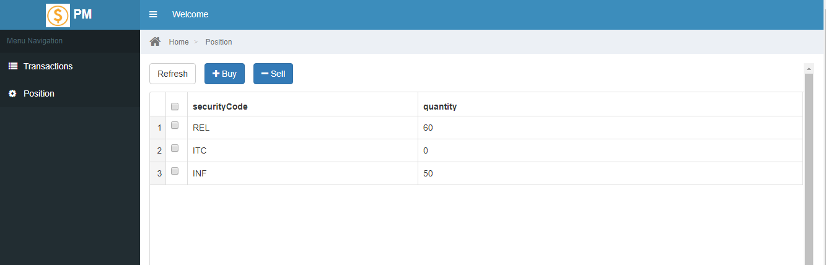

**2.2 transaction change**

**2.1 transaction page**

Display transaction details, this page have Refresh/Modify two buttons

1. When click Refresh button, transaction page should be refreshed
2. When click Modify button, it will navigate to change a transaction record, once submit it, both position and transaction should be changed

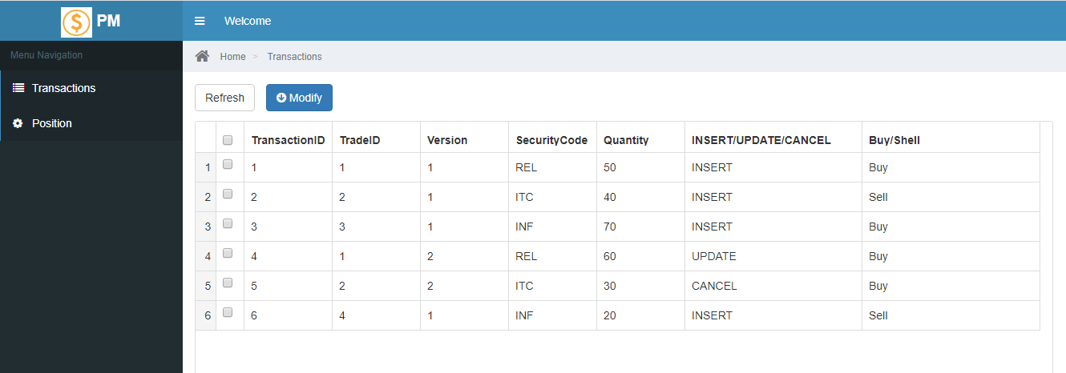

**3. Requirement logic**

**2.1 input description**

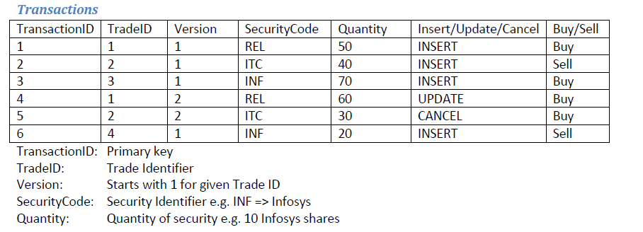

**2.2 output description**

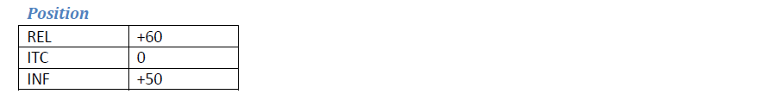

**2.3 Rules:**

